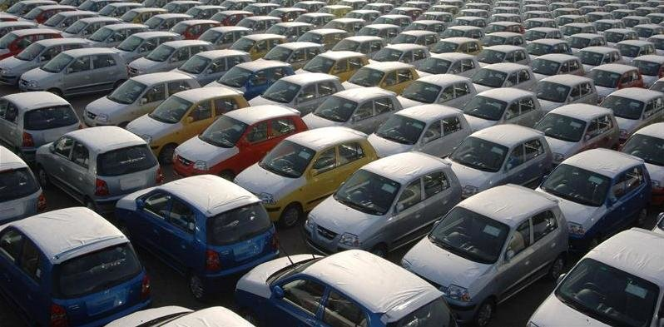

|  |
| --- |
| **Automobiles**  Impact of Science **Ashutosh Varma**CSE (Ist Year)**Roll No. - 01316403218**   The automobile has brought more positive and negative effects than any other invention throughout transportation history. As the most widely accepted method of transportation, cars have changed the way people live all over the world. They have affected all aspects of society such as family life, the economy, and even the environment. It is hard to find a movie, book, or TV show that does not have some type of automobile in it. The advancement of automobiles over time has directly affected the advancement of society as a whole. Over the generations automobiles have influenced every aspect of society in many ways and have changed to keep up with the times. Since the twentieth century, the role of the car has become highly important though controversial. It is used throughout the world and has become the most popular mode of transport in the more developed countries. In developing countries, the effects of the car on society are not as visible, however they are significant. The development of the car built upon the transport sector first started by railways. This has introduced sweeping changes in employment patterns, social interactions, infrastructure and the distribution of goods. The first mass produced automobile became publicly available in the 1920’s. With the advancement in automobile technology, cars made it easier for people to travel in this world, which was beginning to spread out at a rapid pace. They quickly gained fame as the new and fast way to travel. In the beginning, automobiles were considered to be a luxury, but as they became more mass produced, more people were able afford them. Changes that were made in the manufacturing process lowered the cost to the point where the average person could own a vehicle. |
| For Example, in America Ford’s main goal with his assembly line was to make sure that the Model T would be available to a majority of the public. His low production cost enabled the final cost of the car to be lowered as well. “Between 1900 and 1920 Americans went from owning 8,000 cars to owning 8,000,000”. This was largely in part because of lowered production costs.  Automobiles provide access to remote places and mobility comfort, allowing people to geographically increase their social and economic interactions, the negative effects of the car on everyday life are not negligible. Although the introduction of the mass-produced car represented a revolution in industry and convenience, creating job demand and tax revenue, the high motorization rates also brought severe consequences to the society and to the environment. However, average journey times to regularly visited places have increased in large cities, as a result of widespread car adoption and urban sprawl, as well as the decommissioning of older tram systems. The development of the car has contributed to changes in employment distribution, shopping patterns, social interactions, manufacturing priorities and city planning; increasing use of cars has reduced the roles of walking, horses and railroads. In addition to money for roadway construction, car use was also encouraged in many places through new zoning laws that allowed any new business to construct a certain amount of parking based on the size and type of facility. The effect was to create many free parking spaces, and business places further back from the road. In aggregate, this led to less dense settlements and made a carless lifestyle increasingly unattractive. Many new shopping centers and suburbs did not install sidewalks, making pedestrian access dangerous. This had the effect of encouraging people to drive, even for short trips that might have been walkable, thus increasing and solidifying American auto dependency. As a result of this change, employment opportunities for people who were not wealthy enough to own a car and for people who could not drive, due to age or physical disabilities, became severely limited. In countries with major car manufacturers, such as USA or Germany, a certain degree of car dependency might be positive for the economy at a macroeconomic level, since it demands automobile production, therefore resulting also in job demand and tax revenue. These economic conditions were particularly valid during the 1920s when the number of automobiles, worldwide, had a substantial annual average increase, but also during the post–World War II economic expansion. Notwithstanding the growing effects provided by the automobile on the economy of some countries, several other auto-dependent countries, deprived from automobile industry and oil resources, have to allocate substantial economic assets, to satisfy its mobility policies, affecting then their commercial balance. This situation is broadly valid in the majority of the European countries, since, disregarding some few exceptions such as Norway, Europe is largely dependent on imports for its fossil fuels. Furthermore, just few European countries, such as Germany or France, have car manufacturers productive enough to satisfy their country's internal demand for cars. All these factors related to high motorization rates, affect therefore the economic growth in the majority of the European countries. Most African countries are also dependent from imported cars, usually second-hand from Western countries, some of those vehicles being in a very worn-out state. Finally, even countries with oil resources could be deprived of refineries, such as Nigeria which has to import fuel even though it is a major oil producer.  Prior to the appearance of the automobile, horses, walking and streetcars were the major modes of transportation within cities. Horses require a large amount of care, and were therefore kept in public facilities that were usually far from residences. The wealthy could afford to keep horses for private use, hence the term carriage trade referred to elite patronage. Horse manure left on the streets also created a sanitation problem. The motorcycle made regular medium-distance travel more convenient and affordable and after World War I the automobile too, especially in areas without railways. Because cars did not require rest, were faster than horse-drawn conveyances, and soon had a lower total cost of ownership, more people were routinely able to travel farther than in earlier times. The construction of highways in the 1950s continued this. Some experts suggest that many of these changes began during the earlier Golden age of the bicycle, from 1880 to 1915. |

Over time, the car has evolved beyond being a means of transportation or status symbol and into a subject of interest and a cherished hobby amongst many people in the world, who appreciate cars for their craftsmanship, their performance, as well as the vast arrays of activities one can take part in with his/her car. People who have a keen interest in cars and/or participate in the car hobby are known as "Car Enthusiasts”. One major aspect of the hobby is collecting. Cars, especially classic vehicles, are appreciated by their owners as having aesthetic, recreational and historic value. Such demand generates investment potential and allows some cars to command extraordinarily high prices and become financial instruments in their own right. Many car clubs have been set up to facilitate social interactions and companionships amongst those who take pride in owning, maintaining, driving and showing their cars. Many prestigious social events around the world today are centered around the hobby, a notable example is the Pebble Beach Concours d'Elegance classic car show.